**Unit: Manual Motor Controls Test: 5**

**Single-Phase and Three Phase Motors CLO#: 1**

Name ______________________________ Date ______________

**Instructions**

1. Which component of a three-phase motor produces the rotating magnetic field?
   1. Rotor
   2. Squirrel cage
   3. Stator
   4. End Bells
2. The speed of a squirrel cage induction motor depends on
   1. Applied Voltage
   2. The frequency and the number of poles
   3. Magnetic field strength
   4. Current magnitude
3. What is the purpose of the laminated iron plates within the rotor?
   1. Conduct the current induced within them
   2. Reduce Eddy-currents
   3. Reduce hysteresis
   4. B and C
   5. All the above
4. Motors in the US are rated by
   1. NEMA
   2. IEC
   3. NEC
   4. EPA
5. Motors in Europe are rated by
   1. NEMA
   2. IEC
   3. NEC
   4. EPA
6. If a 3HP motor has a service factor of 1.25, what HP can the motor be loaded to?
   1. 3HP
   2. 3.25HP
   3. 3.75HP
   4. Service factor has nothing to do with horsepower.
7. What is motor slip?
   1. The difference between a motors synchronous speed and actual shaft RPM
   2. The difference between the power input to a motor and the actual shaft RPM
   3. The difference between the voltage input to a motor and the actual shaft RPM
   4. The difference between the current input to a motor and the actual shaft RPM
8. What is the effect of operating a motor at a temperature greater than its insulation class?
   1. No effect
   2. Will reduce Life Span
   3. Cause the motor to slow down
   4. Make the motor run faster
9. What is motor efficiency
   1. How fast the shaft turns verses the motors rated RPM
   2. How quickly the motor gets to full speed on startup
   3. How often the motor needs to rest
   4. How well the motor translates electrical power into rotational power
10. When a motor is rated for inverter duty, what does that indicate
    1. It can be used on a solar system
    2. It is a DC motor that will accept an AC input source
    3. It is reversible
    4. It can be used with a variable frequency drive.
11. All NEMA motor nameplates are the same.
    1. True
    2. False
12. A motor has a *Type*. What does this signify?
    1. It’s construction
    2. The type of enclosure the motor has
    3. The means by which the motor is mounted
    4. The type of insulation of the windings
13. A motors *Power Factor (PF)* is useful to determine
    1. The motors efficiency
    2. The motors power requirements
    3. The overall quality of the motor
    4. All of the above
14. A motor is rated at 480V @ 60 Hz. If this motor is installed in England, the motor will
    1. Run slower
    2. Run faster
    3. Overhead
    4. Not work

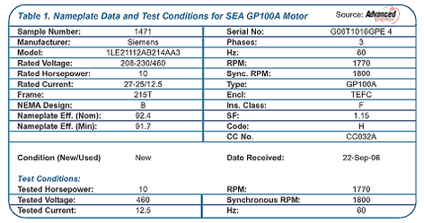

1. What is the horsepower for this motor? __________
2. How many watts should this motor dissipate? ______________
3. What nominal voltage level would you use to connect to this motor to its higher voltage setting? ___________
4. What is the acceptable range of voltage input to this motor if it is connected to it’s highest voltage range? _______ to _______
5. What is the RPM for this motor? ____________
6. If the motor is connected to its higher source voltage it will spin at a higher RPM?
   1. True
   2. False
7. What is the service factor of this motor? __________
8. What is the maximum horsepower output of this motor? (show your math) _______
9. It is safe to run this motor at its max HP for extended periods of time.
   1. True
   2. False
10. Draw a schematic to the right of the motor contactor that indicates its internal components.



1. Compose a truth table and construct the formulas for the control schematic below. HINT: There shall be a formula for the CR1 and for the red light. (CR1 and green light formulas are the same)

